|  |
| --- |
| EPAM Systems, RD Dep. |
| MTN.BI.08 Advanced Refresh Scenarios |

|  |  |  |  |  |  |
| --- | --- | --- | --- | --- | --- |
| REVISION HISTORY | | | | | |
| Ver. | Description of Change | Author | Date | Approved | |
| Name | Effective Date |
| 1.0 | Initial status | [Kiryl Bucha](mailto:Kiryl_Bucha@epam.com) | 12-JAN-2012 |  |  |
| 2.0 | Updated in accordance with renewed content | [Elias Nema](mailto:Elias_Nema@epam.com) | 20-JAN-2014 |  |  |
| 3.0 | Report on the task | Vitaliya Adamchuk | 02-DEC-2017 |  |  |

Contents

1. Business Task – Performance of STAR Scheme 3

1.1. Prepare Report Layout 3

1.2. Compare Report Layout Performance 3

2. Advanced Loading 3

3. ETL Structure 3

# Business Task – Performance of STAR Scheme

## Prepare Report Layout

The Main Task is to create SQL for Report Layout that was developed in the concepts of your business in the last module (Use STAR schema objects for source of Data).

## Compare Report Layout Performance

The Main Task is to create summarize table with comparison Performance of next Report Layout:

* Advancing Grouping (GROUP BY GROUPING SETs – Lab Work 02)
* 3NF (Staging)
* Star Schema (Lab Work 11)

Task Results:

* Prepare Document with description of results.

# Advanced Loading

Implement Fact Table load with use of EXCHANGE PARTITION clause and logic of load for some rolling window period.

# ETL Structure

Create all scripts for ETL Process and store it on next structure:

* Instance name
* Schema name
* Tables
* T_.... (Object name)
* -scripts
* T_.... (Object name)
* -scripts
* Views
* VW_...

**Script example of select for report:**

SELECT fl.dep_time,

fl.dep_delay,

pt.surname,

pt.national_id AS license,

pt.hours_in_air

FROM F_FLIGHT fl

INNER JOIN dm_airlines air

ON fl.carrier=air.icao

INNER JOIN dm_pilot pt

ON fl.pilot_id = pt.pilot_id_seq

WHERE air.icao LIKE '%AAL';

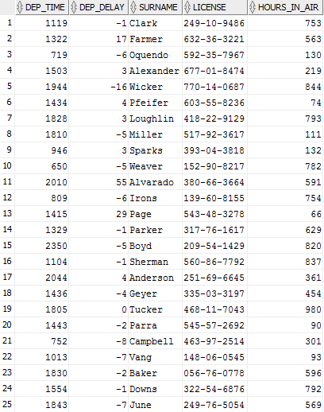

ETL structure:

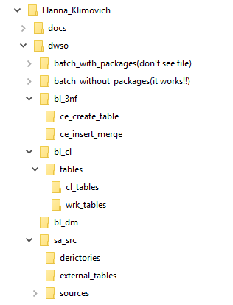

Report layout perfomance:

3nf layer:

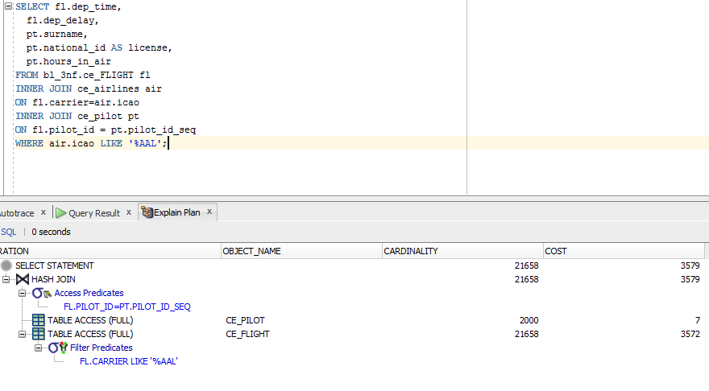

DM layer:

